**Front-End UI/UX Mini Project**

**1. Title Page**

**Project Title:** Daily Journal Layout  
**Submitted By:**

*Vadapalli Lakshmi Kalyani Sahithi (2462370)*

*Sacchit Kallara Viju (2462356)*

**College Email ID:**

[vadapalli.lakshmi@btech.christuniversity.in](mailto:vadapalli.lakshmi@btech.christuniversity.in)

[sacchit.kallara@btech.christuniversity.in](mailto:sacchit.kallara@btech.christuniversity.in)

**Course:** UI/UX Design Fundamentals  
**Instructor Name:** Ms. Nagaveena  
**Institution:** Christ University  
**Date of Submission:** 13/08/2025

**2. Abstract**This project presents the design and implementation of a responsive Daily Journal web application built using HTML5 and custom CSS styling. The application allows users to log daily journal entries, select moods, and visually track mood patterns through a bar chart. It features an archive for past entries, password-protected private entries, nested comment threads, and a theme toggle for dark mode. The design emphasizes accessibility, responsive layout, and an aesthetically pleasing vintage paper style. While the current version is static, it provides a solid foundation for adding features like persistent storage and authentication in the future.

**3. Objectives**

* Log daily journal entries with date, mood, and detailed text.
* Categorize entries by mood for better self-reflection.
* Visualize mood trends through a mood tracker bar chart.
* Provide an archive for browsing past entries.
* Allow password-protected private entries.
* Support responsive and mobile-friendly design.
* Include a dark mode toggle for user preference.
* Maintain an accessible, visually appealing layout.

**4. Scope of the Project**The Daily Journal is a front-end web application that enables users to:

* Write and save daily entries with mood selection.
* Organize entries chronologically in an archive.
* Track mood patterns using visual charts.
* Interact with comments and replies under entries.
* Use a dark/light theme toggle.  
  This version is static and does not yet store entries persistently or support multiple users.

**5. Tools & Technologies Used**

| Tool/Technology | Purpose |
| --- | --- |
| HTML5 | Structure & content markup |
| Custom CSS | Styling, responsiveness, and theme toggling |
| Google Fonts | Custom typography |
| VS Code | Code editing |
| Chrome DevTools | Testing & debugging |

**6. HTML Structure Overview**

* Semantic HTML5 elements used: <header>, <section>, <nav>, <article>, <div>.
* Sections:
  + New Entry: Form for date, mood, and journal text.
  + Archive: List of past entries with mood tags, comments, and password-protected posts.
  + Stats: Summary of entry count and streak.
  + Mood Tracker: Bar chart visualization of moods.
* The layout is designed to be responsive for both desktop and mobile views.

**7. CSS Styling Strategy**

* Custom CSS for layout, mood color-coding, hover effects, and animations.
* Mood-specific left borders for visual mood categorization.
* Dark mode implemented using a toggle with the :has() selector.
* Media queries for mobile optimization.
* Vintage paper background for a warm, journal-like aesthetic.

**8. Key Features**

| Feature | Description |
| --- | --- |
| Journal Entry Form | Add new entries with date, mood, and notes. |
| Mood Categorization | Assign moods with color-coded indicators. |
| Archive | Chronologically organized past entries. |
| Comments & Replies | Nested thread structure under entries. |
| Password-Protected Entries | Lock sensitive entries with a password prompt. |
| Mood Tracker | Bar chart showing mood distribution. |
| Dark Mode | Switch between light and dark themes. |
| Responsive Design | Optimized for all screen sizes. |

**9. Challenges Faced & Solutions**

| Challenge | Solution |
| --- | --- |
| Maintaining readability with background textures | Used semi-transparent content backgrounds. |
| Implementing dark mode without JS | Utilized :has() selector for theme switching. |
| Designing mood-specific color coding | Applied custom CSS with [data-mood] attributes. |
| Organizing nested comments | Used nested flexbox layouts for replies. |
| Ensuring mobile usability | Added media queries for single-column layouts. |

**10. Outcome**

* Developed a functional and visually pleasing journal interface.
* Achieved full responsiveness and mobile usability.
* Created mood-based visual tracking through bar charts.
* Built a strong design base for adding interactivity and storage.

**11. Future Enhancements**

* Backend storage for persistent entries.
* User authentication for privacy.
* Advanced search and filtering options.
* Calendar view for entry navigation.
* Rich-text editor for journal entries.
* More detailed mood analytics.

**12. Sample Code**

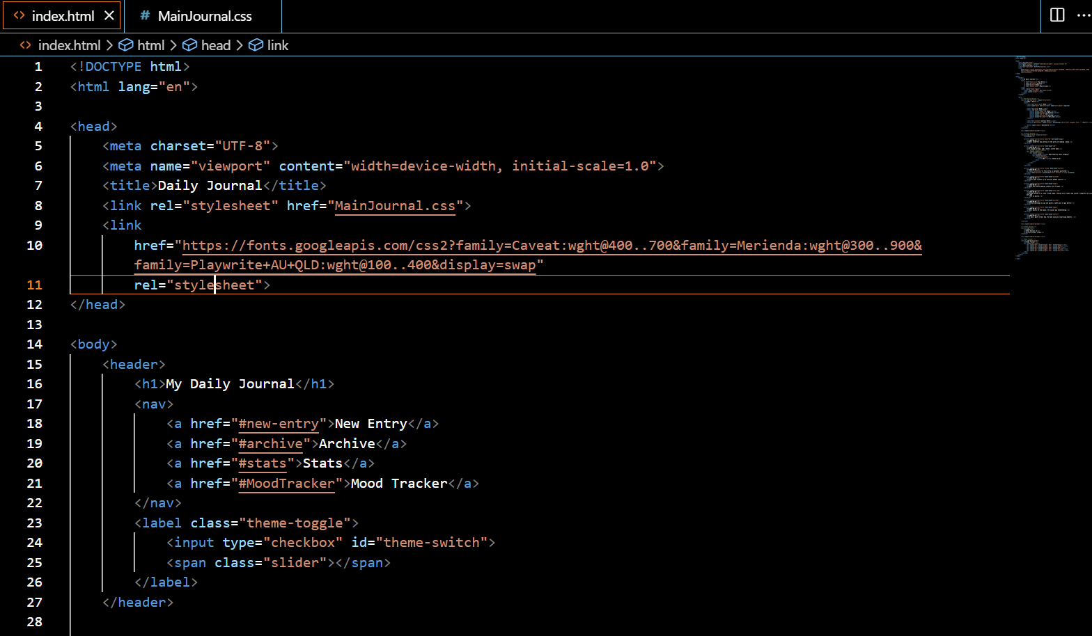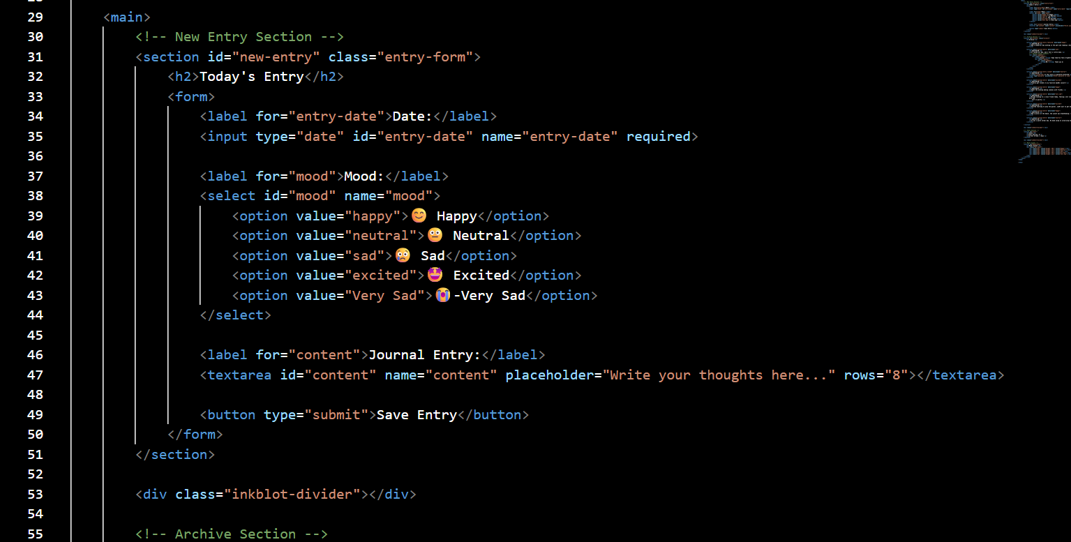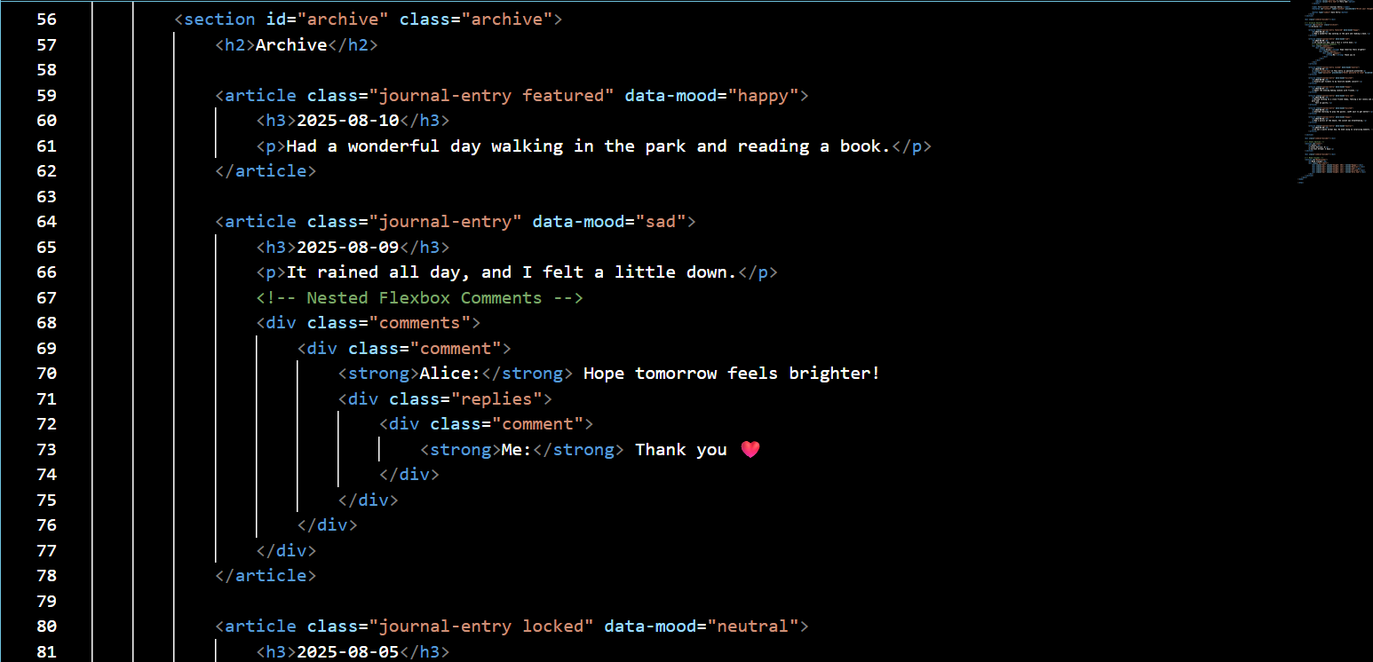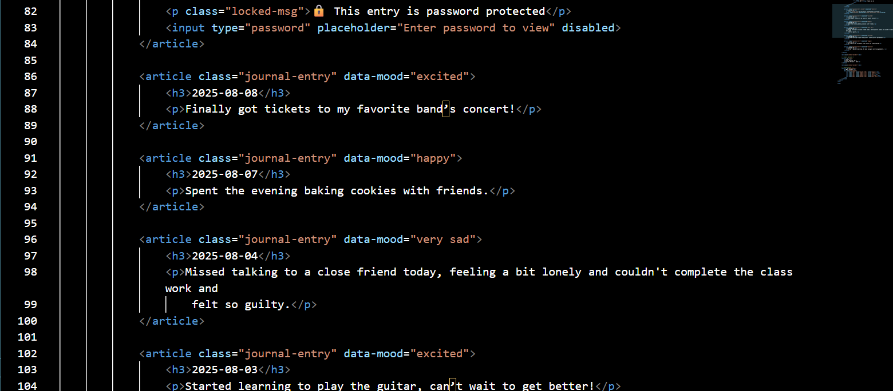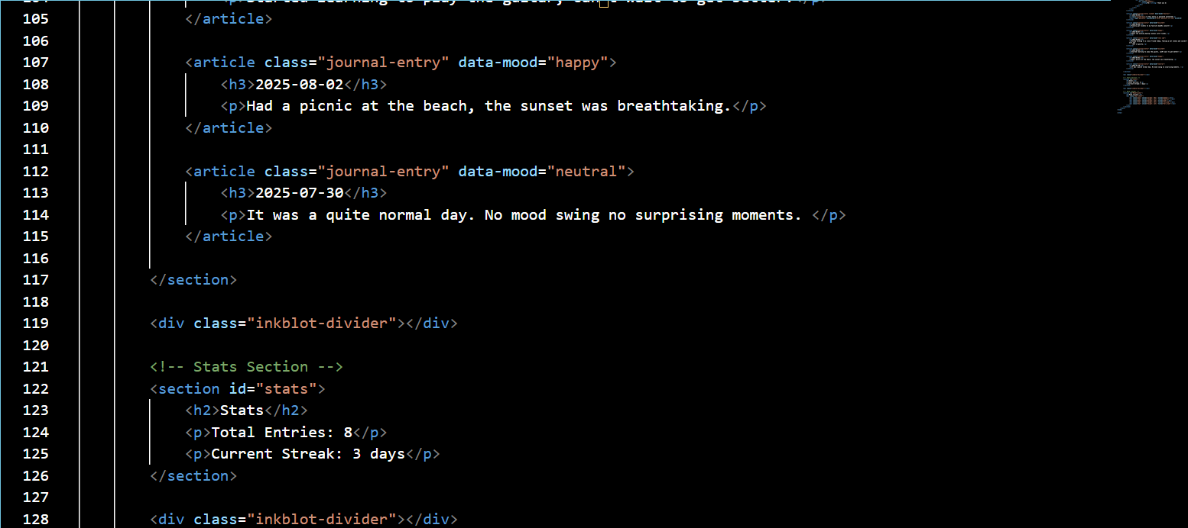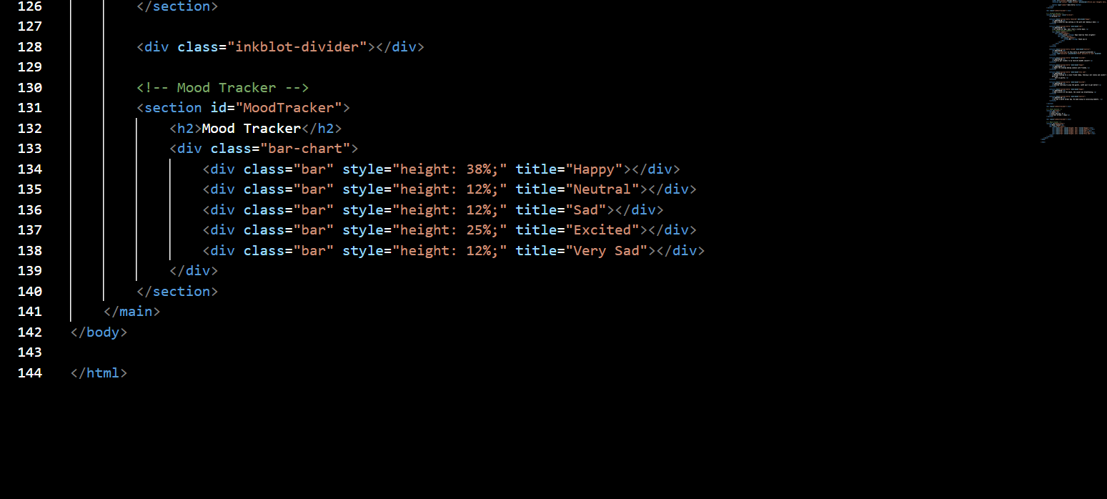

**13. Screenshots of Final Output**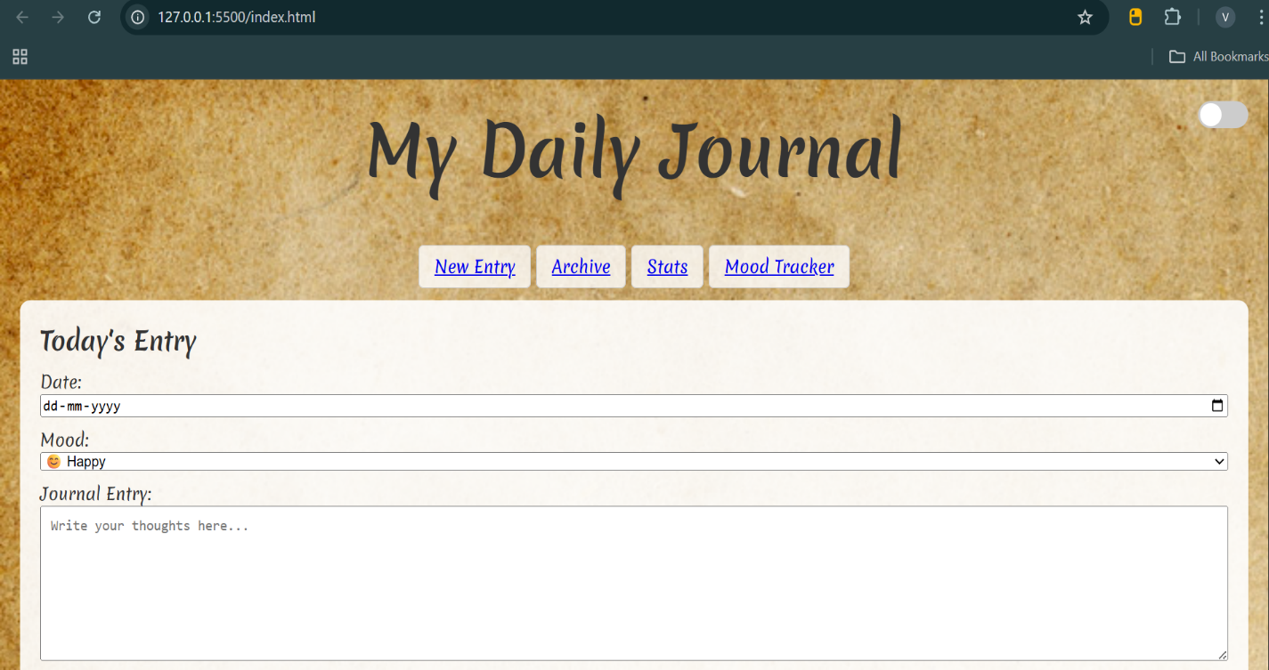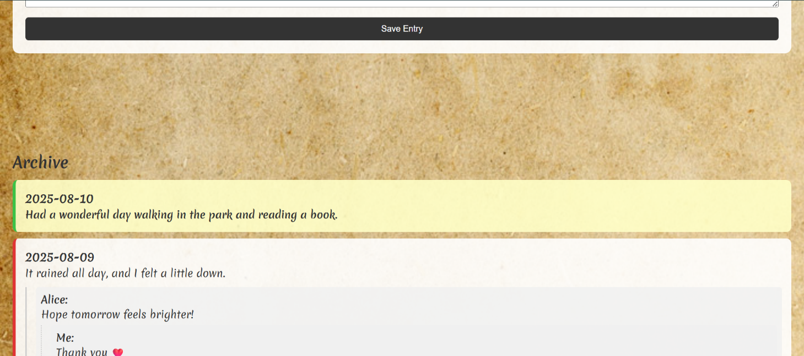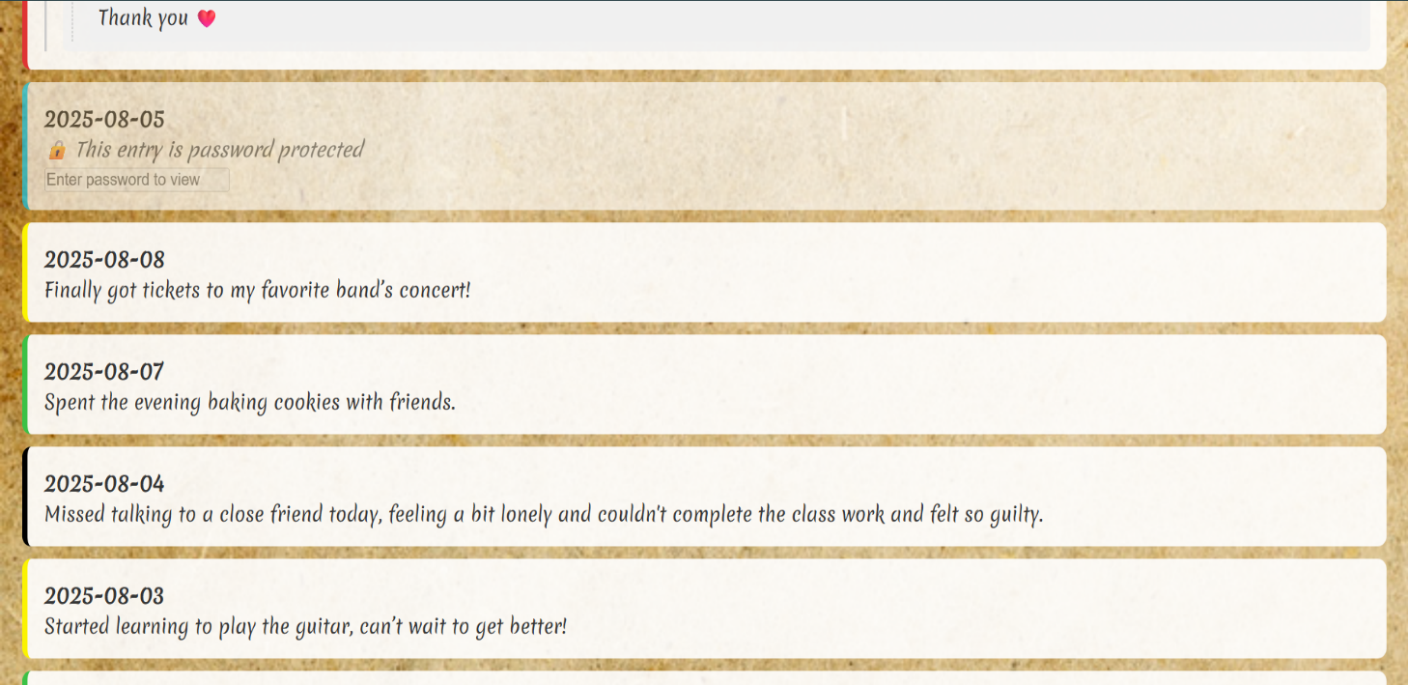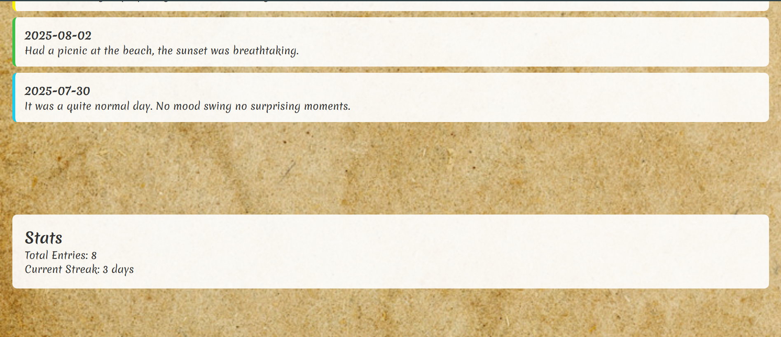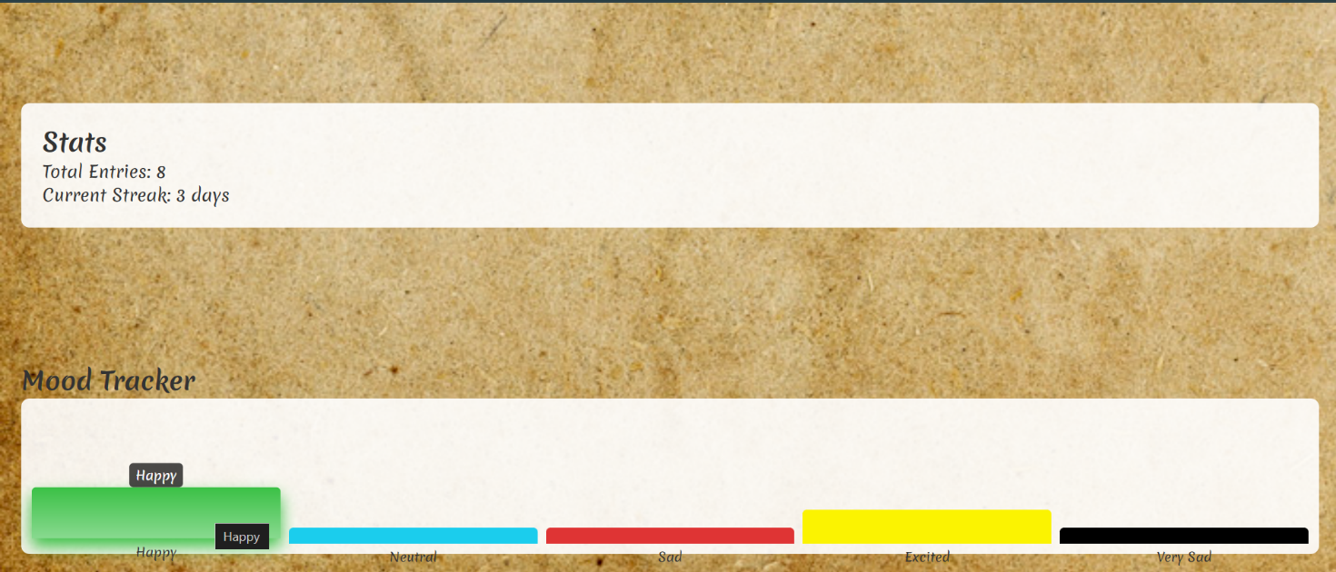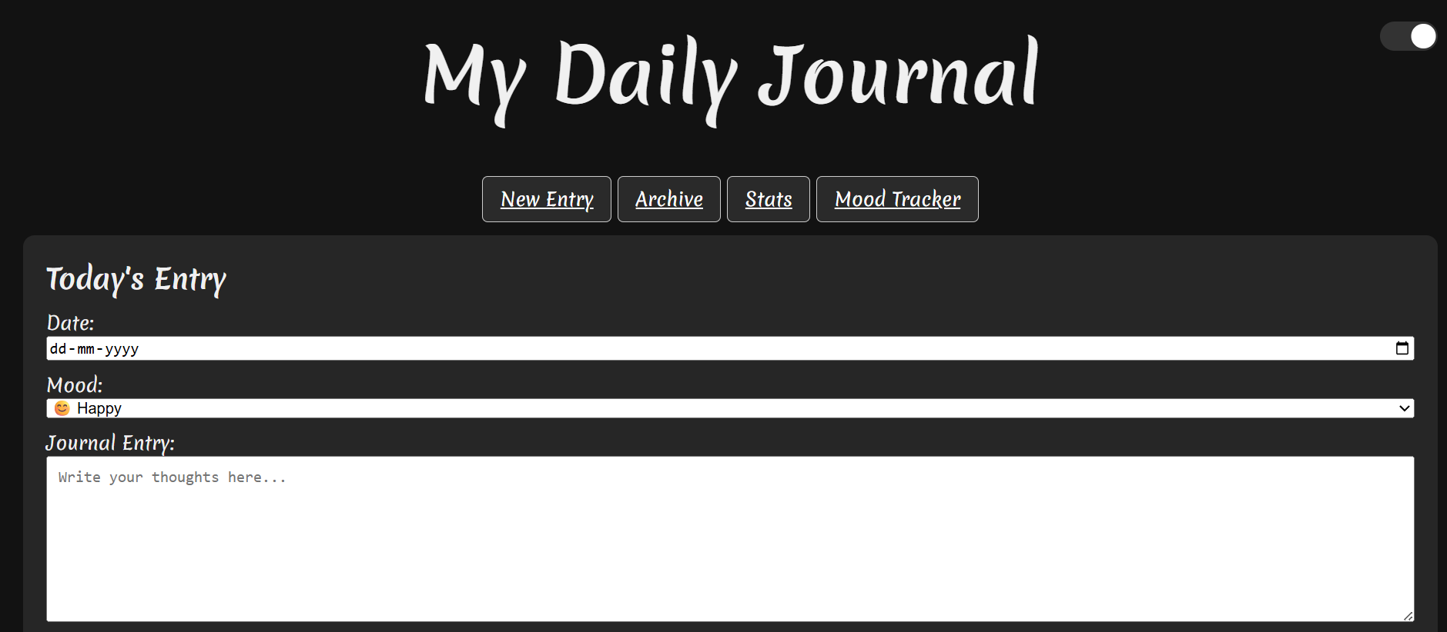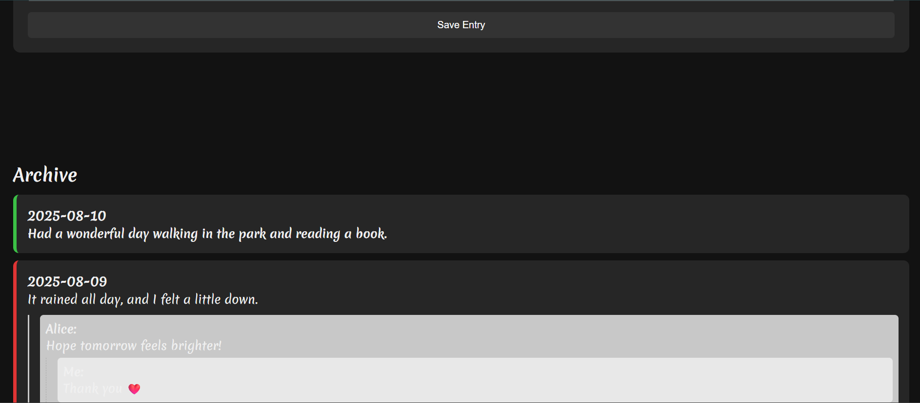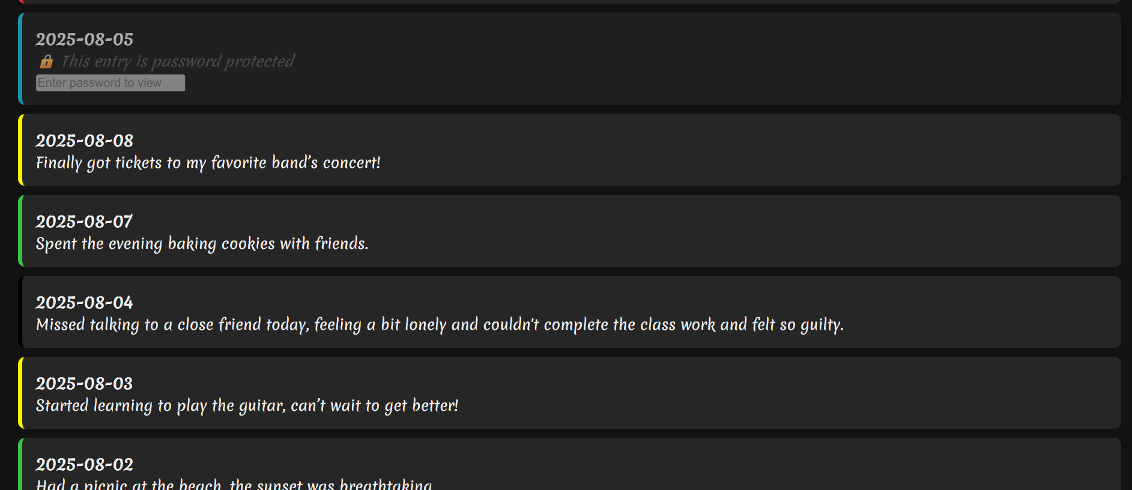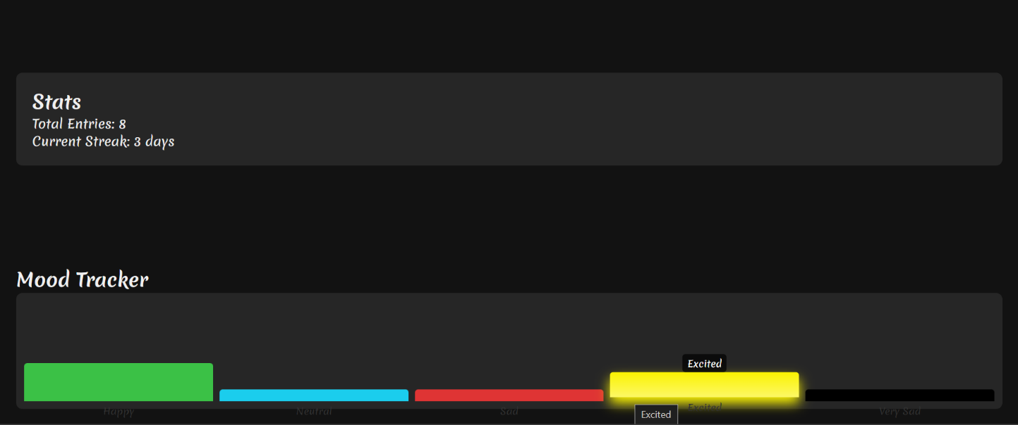

**14. Conclusion**The Daily Journal provides a clean, responsive, and visually engaging platform for recording and reflecting on daily experiences. Built with HTML5 and custom CSS, it emphasizes both functionality and aesthetics through features like mood selection, password-protected entries, an archive, and a mood tracker chart. The interface is intuitive, mobile-friendly, and designed with accessibility in mind. While the current version is static, it establishes a strong foundation for future enhancements such as persistent storage, user authentication, and advanced analytics, making it a scalable solution for personal journaling needs.

**15. References**

* MDN Web Docs – <https://developer.mozilla.org>
* W3Schools HTML & CSS References – https://www.w3schools.com
* Google Fonts – https://fonts.google.com